**EXPERIMENT-2**

**Title:** To understand and apply the concept of Constraints.

**Objective:** To understand the concept of data constraints that is enforced on data being stored in the table. Focus on Primary Key and the Foreign Key.

**1. Create the following table.**

Table name: CLIENT_MASTER_1

Code:

use lab_work;

create table CLIENT_MASTER_1 (

CLIENTNO Varchar (6) primary key check(CLIENTNO like '%c'),

NAME1 Varchar (20) not null,

ADDRESS1 Varchar (30),

ADDRESS2 Varchar (30),

CITY Varchar (15),

PINCODE Integer (8),

STATE Varchar (15),

BALDUE Decimal (10,2)

);

Table Name: PRODUCT_MASTER_1

Code:

use lab_work;

CREATE TABLE PRODUCT_MASTER_1(

PRODUCTNO Varchar (6) Primary Key check( PRODUCTNO like '%p'),

DESCRIPTIONS Varchar (15) Not Null,

PROFITPERCENT Decimal (4,2) Not Null,

UNIT_MEASURE Varchar (10) Not Null,

QTYONHAND Integer (8) Not Null,

REORDERL_VL Integer (8) Not Null,

SELLPRICE Decimal (8,2) Not Null,

COSTPRICE Decimal (8,2) Not Null

);

Table Name: SALESMAN_MASTER _1

Code:

use lab_work;

CREATE TABLE SALESMAN_MASTER_1(

SALESMANNO Varchar (6) Primary Key check(SALESMANNO like '%s') ,

SALESMANNAME Varchar (20) Not Null,

ADDRESS1 Varchar (30) Not Null,

ADDRESS2 Varchar (30),

CITY Varchar (20),

PINCODE Integer (8),

STATE Varchar (20),

SALAMT Real (8,2) Not Null check(SALAMT!=0),

TGTTOGET Decimal (6,2) Not Null check(TGTTOGET!=0),

YTDSALES Double (6,2) Not Null,

REMARKS Varchar (60)

);

**2. Reinsert the data in these tables.**

Table name: CLIENT_MASTER_1

Code:

use lab_work;

INSERT INTO CLIENT_MASTER_1

VALUES('c00001', 'Ivan bayross','ANDHERI ','EAST', 'Mumbai', 400054, 'Maharashtra', 15000),

('c00002', 'Mamta muzumdar', 'Shanthi Colony Main Road','AI Block','Madras', 780001, 'Tamil nadu', 0),

('c00003', 'Chhaya bankar','ANDHERI','WEST', 'Mumbai', 400057 ,'Maharashtra' ,5000),

('c00004', 'Ashwini joshi', 'Sarvepalli Radhakrishnan Rd','Soladevanahalli', 'Bangalore', 560001, 'Karnataka', 0);

Table Name: PRODUCT_MASTER_1

Code:

use lab_work;

INSERT INTO PRODUCT_MASTER_1

VALUES('P00001', 'T-Shirt', 5 , 200,50, 350, 250,56),

('P0345', 'Shirts', 6, 150 ,50 ,500, 350,53),

('P06734' ,'Cotton jeans' ,5 ,100 ,20 ,600,450,54),

('P08865' ,'Skirts ',5 ,75 ,30 ,450 ,300,64);

Table Name: SALESMAN_MASTER _1

Code:

use lab_work;

INSERT INTO SALESMAN_MASTER_1

VALUES( 's00001' ,'Aman' ,'A/14','Worli','Mumbai',400002,'Maharashtra',56.0,85.5,556.0,'Na'),

('s00002', 'Omkar','65','Nariman', 'Mumbai', 400001, 'Maharashtra',78.0,44.8,564.0,'NA'),

('s00003' ,'Raj' ,'P-7', 'Bandra','Mumbai',400032 ,'Maharashtra',75.0,98.0,435.5,'Na'),

('s00004' ,'Ashish' ,'A/5','Juhu','Mumbai',400044 ,'Maharashtra',74.5,55.2,554.3,'Na');

**3. Display the contents of each table**

Code:

use lab_work;

select * from CLIENT_MASTER_1 ;

select * from PRODUCT_MASTER_1;

select * from SALESMAN_MASTER_1;

Output:

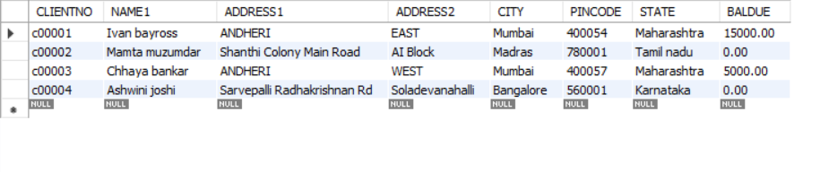**CLIENT_MASTER_1**

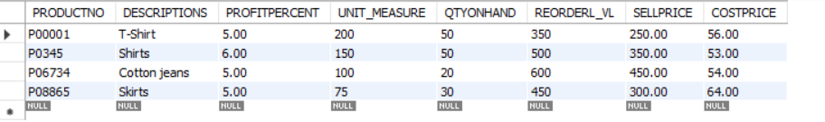

**PRODUCT_MASTER_1**

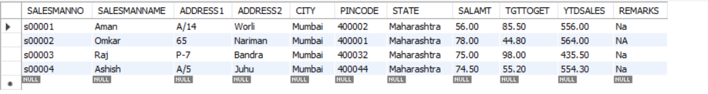

**SALESMAN_MASTER_1**

**4. Create table AUTHOR = {Author_ID , Lastname, Firstname, Email, City, Country}**

Code:

use lab_work;

CREATE TABLE AUTHOR

(

Author_ID varchar(5) primary key,

Lastname varchar(15),

Firstname varchar(15),

Email varchar(40),

City varchar(15),

Country varchar(15)

);

**5. Create Table BOOK={ Book_ID, Book_Title, Copies}**

Code:

use lab_work;

CREATE TABLE BOOK

(

Book_ID varchar(5) primary key check(Book_ID like 'B%'),

Book_Title varchar(30) not null,

Copies int check(copies >2)

);

**6. Create table AUTHOR_LIST = {Author_ID , Book_ID , Role}**

Code:

use lab_work;

CREATE TABLE AUTHOR_LIST(

Author_ID varchar(5) references AUTHOR(Author_ID),

Book_ID varchar(5) references BOOK(Book_ID),

Roles varchar(15),

primary key(Author_ID,Book_ID)

);

**7. Add four records in each tables AUTHOR, BOOK, Author_LIST.**

Table Name: AUTHOR

Code:

use lab_work;

INSERT INTO AUTHOR

VALUES ('A0001','Khan','Haseen','haseen@gmail.com','Dehradun','India'),

('A0002','kumar','Kishore', 'kishore@gmail.com','Delhi','India'),

('A0003','Pant', 'Gaurav', 'gaurav@gmail.com', 'Mumbai','India'),

('A0004', 'Katariya', 'Pal', 'Pal@gmail.com', 'Goa', 'India');

Table Name: BOOK

Code:

use lab_work;

INSERT INTO BOOK

VALUES ( 'B0001', 'xyz', 5),

('B0002', 'abc', 8),

('B0003', 'def',9),

('B0004','jkl',6);

Table Name: AUTHOR_LIST

Code:

use lab_work;

INSERT INTO AUTHOR_LIST

VALUES ('A0001','B0001', 'xyz'),

('A0002','B0002', 'abc'),

('A0003','B0003', 'def'),

('A0004','B0004', 'jkl');

**8. Alter structure of table AUTHOR_LIST add the field Publisher data type of 30 Character.**

Code:

use lab_work;

alter Table AUTHOR_LIST Add Publisher varchar(30);